6-3 Inner versus Outer Joins

Vocabulary

|  |  |
| --- | --- |
| FULL OUTER | Performs a join on two tables, retrieves all the rows in the Left table, even if there is no match in the Right table. It also retrieves all the rows in the Right table, even if there is no match in the Left table. |
| OUTER JOIN | A join that returns the unmatched rows as well as matched rows |
| LEFT OUTER | Performs a join on two tables, retrieves all the rows in the Left table even if there is no match in the Right table |
| RIGHT OUTER | Performs a join on two tables, retrieves all the rows in the Right table even if there is no match in the Left table |
| INNER | A join of two or more tables that returns only matched rows |

Try It / Solve It

1. Return the first name, last name, and department name for all employees including those employees not assigned to a department.

1. Return the first name, last name, and department name for all employees including those departments that do not have an employee assigned to them.

1. Return the first name, last name, and department name for all employees including those departments that do not have an employee assigned to them and those employees not assigned to a department.

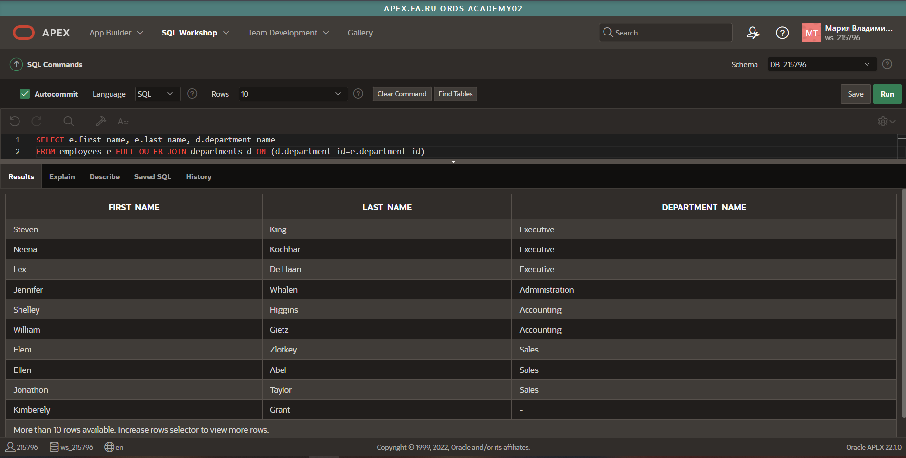

1. Create a query of the DJs on Demand database to return the first name, last name, event date, and description of the event the client held. Include all the clients even if they have not had an event scheduled.

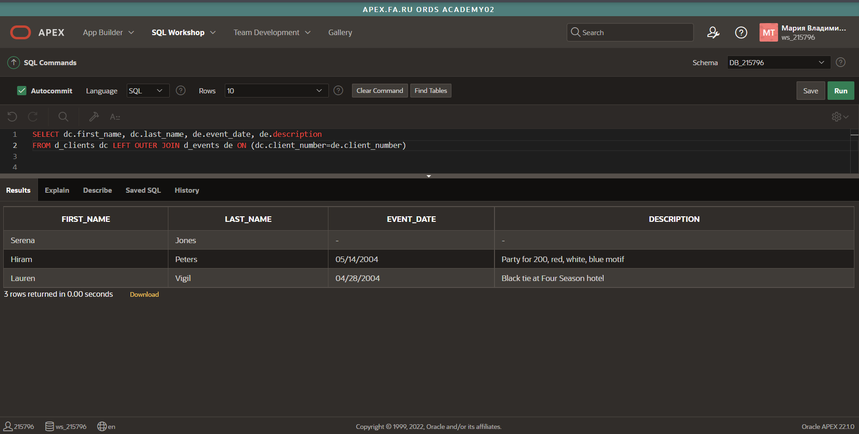

1. Using the Global Fast Foods database, show the shift description and shift assignment date even if there is no date assigned for each shift description.

